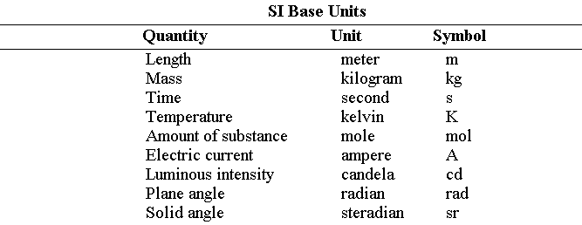

ASSAS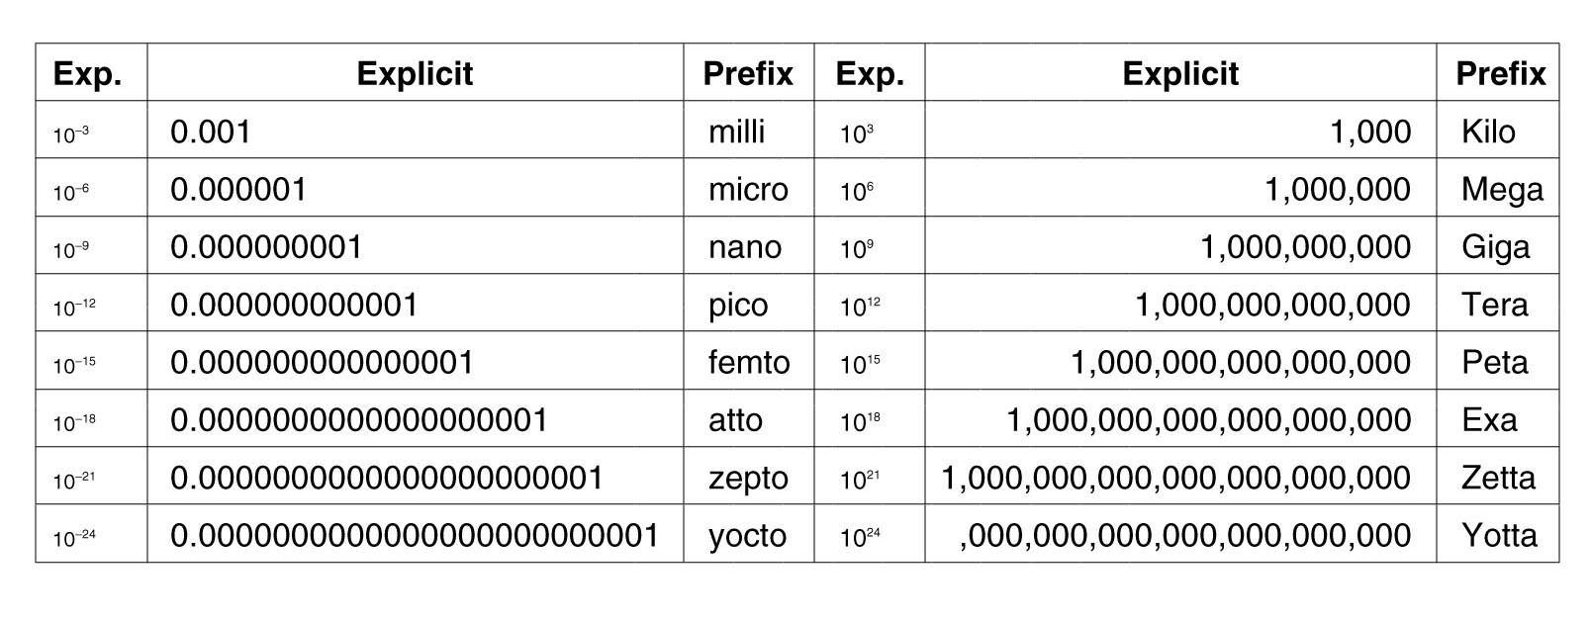

Scalar is a quantity possessing only magnitude.

Vector is a quantity possessing both magnitude and direction.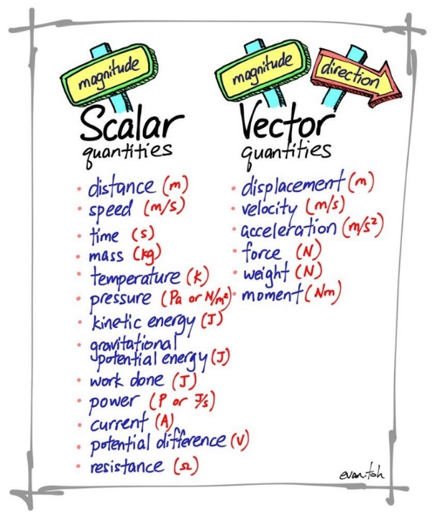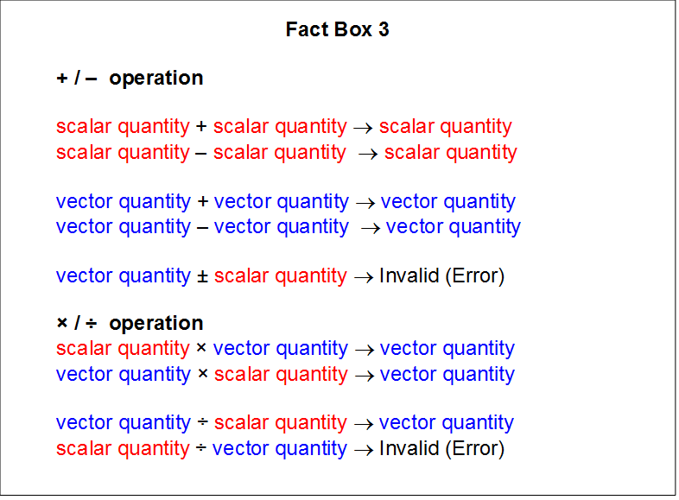

Si Derived Units

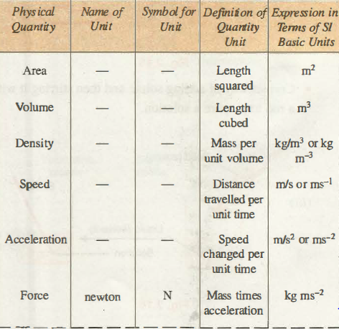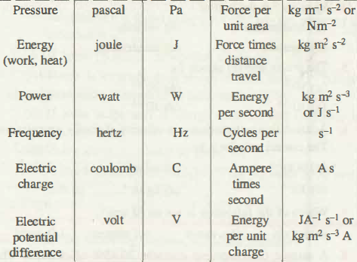

|  |  |
| --- | --- |
| Image result for basic trigonometry formula | Related image |

Acceleration

Imagine you are on a train. If it is sitting at the station, not moving, that would be a zero velocity AND zero acceleration. The instant it takes off from the station, it will have a zero-VELOCITY, but a non-zero Acceleration. As it continues to accelerate it will have a non-zero velocity AND a non-zero acceleration. Once it reaches it's cruising speed, if there is nothing effecting the train, it will have a non-zero velocity but a ZERO ACCELERATION.  
  
Reference <https://www.physicsforums.com/threads/non-zero-velocity.532791/>

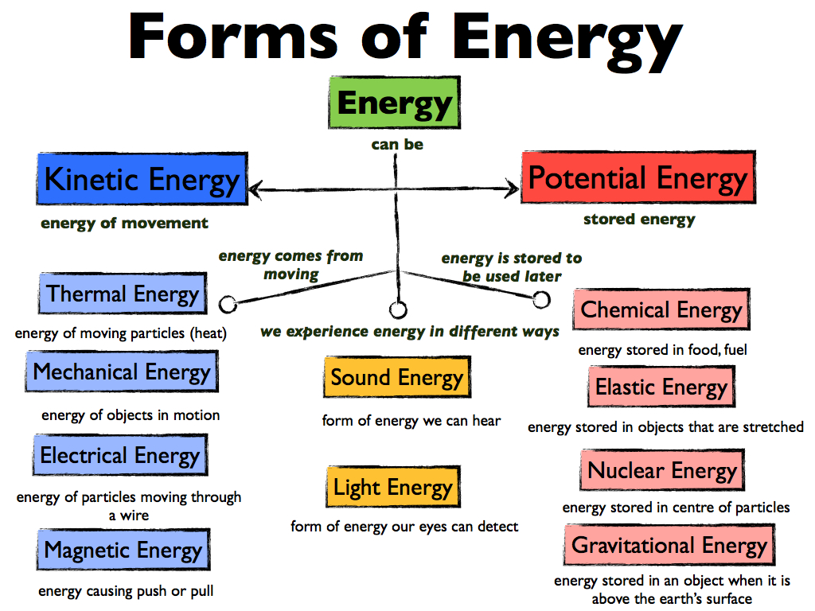

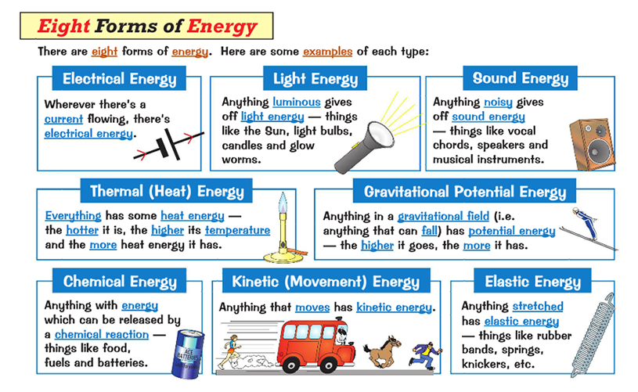

* + - 1. Gravitational potential energy - **Gravitational potential energy** is **energy** an object possesses because of its position in a **gravitational** field.
      2. Kinetic Energy - **Kinetic energy** is the **energy** an object has because of its motion.
      3. Mechanical Energy - **Mechanical energy** is the sum of kinetic and potential **energy** in an object that is used to do work. In other words, it is **energy** in an object due to its motion or position, or both.
      4. Chemical energy - **Chemical Energy** is **energy** stored in the bonds of **chemical** compounds (atoms and molecules).
      5. Potential energy - **Potential energy definition**, the energy of a body or a system with respect to the position of the body or the arrangement of the particles of the system.
      6. Elastic energy - **Elastic potential energy** is **Potential energy** stored as a result of deformation of an **elastic** object, such as the stretching of a spring.
      7. Nuclear Energy - **Nuclear energy,**also called **Atomic Energy**, [energy](https://www.britannica.com/science/energy) that is released in significant amounts in processes that affect atomic nuclei, the dense cores of atoms.
      8. Sound energy - **Sound energy** is a form of **energy** associated with the vibration of matter.
      9. Magnetic Energy - **Magnetic energy** is the energy within a magnetic field. This energy results in various metals either repelling or attracting each other.
      10. Light Energy - **Light energy** is a type of kinetic energy with the ability to form types of light people can see as well as invisible waves.
      11. Thermal energy - **Thermal energy** is the **energy** that comes from heat. This heat is generated by the movement of tiny particles within an object. The faster these particles move, the more heat is generated.
      12. Electromagnetic Energy – **Electromagnetic energy** is a form of **energy** that is reflected or emitted from objects in the form of electrical and magnetic waves that can travel through space. There are many forms of**electromagnetic energy** including gamma rays, x rays, ultraviolet **radiation**, visible light, infrared **radiation**, microwaves and radio waves.
      13. Electrostatic Energy - **Electrostatic** potential **energy**, is potential **energy**(measured in joules) that results from conservative Coulomb forces and is associated with the configuration of a particular set of point charges within a **defined** system
      14. Ionization Energy - **Ionization energy** is the **energy** required to remove an electron from a gaseous atom or ion.
      15. Surface Energy - The **surface energy** is **defined** as the sum of all intermolecular forces that are on the **surface** of a material, the degree of attraction or repulsion force of a material **surface** exerts on another material.
      16. Quantum chromodynamics binding energy - The **quantum chromodynamics binding energy** (**QCD binding energy**) is the [energy](https://en.wikipedia.org/wiki/Energy) binding [quarks](https://en.wikipedia.org/wiki/Quark) together into [hadrons](https://en.wikipedia.org/wiki/Hadron). It is the energy of the [field](https://en.wikipedia.org/wiki/Field_(physics)) of the [strong force](https://en.wikipedia.org/wiki/Strong_force), which is mediated by [gluons](https://en.wikipedia.org/wiki/Gluon).
      17. Solar Energy - **Solar energy** is any type of energy generated by the sun. Solar energy is created by nuclear fusion that takes place in the sun. Fusion occurs when protons of hydrogen atoms violently collide in the sun’s core and fuse to create a helium atom.

Relativistic Energy - The **relativistic energy** expression includes both rest mass **energy** and the kinetic **energy** of motion. The kinetic **energy** is then given by. This is essentially **defining** the kinetic **energy** of a particle as the excess of the particle **energy**

Bernoulli’s equation

While the train is moving by, it is causing fluctuations in the surrounding air pressure. Also, it is causing air to move faster near the train, and faster moving air creates a low pressure. That low pressure exists along the side of the train. The slower or non-moving air between you and the train will flow from that higher pressure to the lower pressure; thus it will push you into the train. (This is Bernoulli's Principle)

If you have a strong enough magnetic field all matter is magnetic. But copper is so weakly magnetic that we can't observe it without very, very large magnetic fields. So the short answer is "No, copper isn’t magnetic." This can quickly be tested by trying to pick up a penny with a magnet.